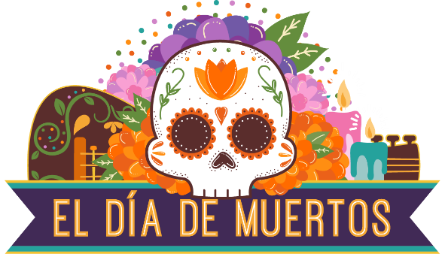

2021 Community Collaboration Opportunities

The annual Día de Muertos celebration continues to grow each year as more families and individuals take part in activities offered by a variety of community members, organizations, and businesses.
Poudre River Public Library District is excited to coordinate this year’s celebration in partnership with our Fort Collins and northern Colorado community. By combining all of our resources and promotion, together we can create an amazing Día de Muertos experience for everyone.
Please let us know how you’d like to be involved – there are a variety of ways for your organization to participate and support Día de Muertos programming and education. We look forward to working with you!

DATES: October 18 - November 6, 2021
LOCATION: Virtual (Zoom) with some in-person activities as allowed for health and safety

CONTACTS: Ludy Rueda, lrueda@poudrelibraries.org, programming / activity collaboration
Africa Garcia, agarcia@poudrelibraries.org, programming / activity collaboration
Angela Kettle, akettle@poudrelibraries.org, sponsorship and donation

Collaboration Opportunities
Here are just a few of the ways your organization or group can participate.

- Organize a book club
- Help find program sponsors
- Organize a car caravan
- Organize a community parade
- Set an altar
- Coordinate community altars
- Host a program
- Host a nicho (storage and display)
- Organize a 5K run/walk
- Organize papel picado in downtown Fort Collins
- Organize celebration banners in downtown Fort Collins
- Set up a large altar behind a window
- Make sugar skulls for families to decorate
- Host a food drive
- Identify presenters
- Provide a photographer
- Provide venue for community celebration / individual program
- Recruit volunteers
- Organize a vigil at cemetery
- Donate goods or services
- Other – your ideas are welcome

2021 Día de Muertos Community Collaboration

As an official collaborator on Día de Muertos, you / your organization will receive*:
- Listing in event press releases sent out by the Library District
- Logo on select print and online marketing materials (deadline August 15, 2021)
- Logo or company/organization name on Día de Muertos website (www.nocodiademuertos.org)
- Listing in the website schedule of events
- Acknowledged in Library District blog post and highlighted on social media

Promotional materials are time sensitive, with some materials needing to go to print earlier than others. Deadline for submission is August 15, 2021. After this date, we cannot guarantee that you’ll be included in all marketing opportunities. However, you will be included on the website and other digital promotions.

*Please note: The Library District does not promote programs or activities that require a fee or a purchase. If your program or activity has a cost, you will still be included on the Día de Muertos website, but not through Library-owned communications channels.

Complete the online form to have your program/activity added to the website schedule of events and included in other marketing materials. You may submit multiple forms for additional programs and activities.

Link to Google Form: https://forms.gle/BLHDbXyssQgTimsj8.

If you would like your logo included on marketing materials, send a high-res PDF, png, or jpg file to Angela Kettle: akettle@poudrelibraries.org.

Thank you for your support! We could not do this without you!

