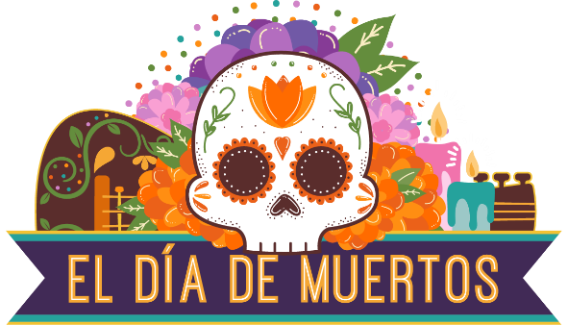

2021 Sponsorship / Donation Opportunities

The annual Día de Muertos celebration continues to grow each year as more families and individuals take part in activities offered by a variety of community members, organizations, and businesses. Poudre River Public Library District is excited to coordinate this year’s celebration in partnership with our Fort Collins and northern Colorado community.
Sponsoring the 2021 Día de Muertos celebration is a wonderful opportunity for local businesses and organizations to support diverse, cultural programming in our community and reach out to our Latinx friends and neighbors.
Please let us know how you’d like to be involved. We look forward to working with you!

DATE: October 18 – November 6, 2021

LOCATION: Virtual (Zoom) with some in-person activities as allowed for health and safety

WEBSITE: www.nocodiademuertos.org

CONTACTS: Katie Auman, kauman@poudrelibraries.org
Angela Kettle, akettle@poudrelibraries.org

Sponsorship Opportunities
Here are just a few of the ways your organization or group’s sponsorship will benefit the event.

- Donate goods or services (e.g., food, beverages, equipment rental, venue, and more)
- Sponsor t-shirts for staff and volunteers
- Sponsor a movie at The Lyric or a community drive-in movie screening
- Sponsor a specific presenter or program
- Sponsor / donate supplies (e.g., makeup)
- Other – we welcome your ideas!

2021 Día de Muertos Sponsorship Opportunities

Friend of the Festival Sponsor
$100 or more monetary sponsorship
- Logo listed on festival website in the sponsor page
- Logo/name listed on any specific program or activity that you sponsor
- Acknowledgement in promotional materials such as news releases, blogs, etc.

In-Kind Donations
$100 or more Products and Services Donation Sponsor
- Sponsor name/logo listed on festival website in the sponsor page
- Sponsor name/logo displayed near donated goods/products

Media Trade Sponsorships
Please email Katie Auman (kauman@poudrelibraries.org) or Angela Kettle (akettle@poudrelibraries.org) to discuss these opportunities.

2021 Día de Muertos Community Sponsorship Agreement

Business/Organization:
Address:
Name of Contact:
Phone:
Email:

YES! I/we would like to sponsor Día de Muertos as a (check one below):
☐ Friend of the Festival Sponsor
☐ In-Kind Product or Service Donation Sponsor
☐ Media Trade Sponsor

Payment Options
☐ Enclosed is a check in the amount of $
Make check payable to: Poudre River Public Library District
Poudre River Public Library District
Attn: Katie Auman
301 East Olive St.
Fort Collins, Colorado 80524
☐ Please send me an invoice for the sponsorship in the amount of $

Thank you for your support! We could not do this without you!

